Underexposed: Women Photographers from the Collection
Image Credits
Reproduction guidelines:
• These images are for one-time, non-commercial publicity purposes only.
• This does not include “exclusive rights.”
• No further reproduction will be made without additional permission.
• Images may not be cropped or changed. Dimensions must be retained. Text overlay is not permitted.
• The images may only be used in conjunction with press coverage of the High’s presentation of Underexposed: Women Photographers from the Collection.
• Images must be accompanied by the credit lines below.
• For online uses, image must have a maximum resolution of 72 dpi.
• By downloading the image(s), you acknowledge you have read and accept the terms of the guidelines.
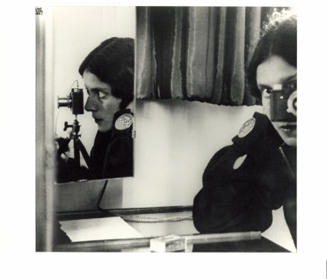
- Ilse Bing (American, born Germany, 1899-1998), Self-Portrait in Mirrors, Paris, 1931, printed ca. 1941, gelatin silver print, High Museum of Art, Atlanta, purchase with funds from Georgia-Pacific Corporation, 1987.14

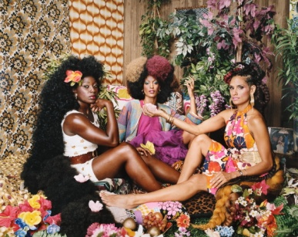
- Mickalene Thomas (American, born 1971), Les Trois Femmes Deux, 2018, dye coupler print, High Museum of Art, Atlanta, purchase with funds from the Friends of Photography, 2018.214

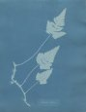

- Anna Atkins (British, 1799-1871), Mauritius, from Cyanotypes of British and Foreign Flowering Plants and Fern, 1851-1854, cyanotype, 10 1/8 x 7 15/15 inches, Gift in honor of Edward Anthony Hill, 2019.1

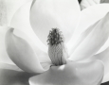
- Imogen Cunningham (American, 1883-1976), Magnolia Blossom, 1975, gelatin silver print, 10 ¼ x 13 inches, purchase with funds from a Friend of the Museum, © The Imogen Cunningham Trust

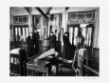
- Berenice Abbott (American, 1898-1991), "El" Station Interior, Sixth and Ninth Avenue Lines, Downtown Side, 1936, gelatin silver print, 10 3/8 x 13 3/8, purchase with funds from a Friend of the Museum, 74.57

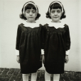
- Diane Arbus (American, 1923-1971), Identical Twins, Cathleen (L) and Colleen, Members of a Twin Club in N.J., 1966, printed 1970, gelatin, silver print. High Museum of Art, Atlanta, purchase with funds from a friend of the Museum, ©Estate of Diane Arbus, 74.81 G
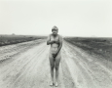
- Judy Dater (American, born 1941), Self-Portrait on Deserted Road¸ 1982, gelatin silver print, 14 ¼ x 18 ¼, Gift of Lucinda W. Bunnen for the Bunnen Collection, 1982.274

- Paula Chamlee (American, born 1944), Nude Collage #1, 1998, gelatin silver print, 7 ¾ x 9 ½, Gift of Lucinda W. Bunnen for the Bunnen Collection, ©Paula Chamlee, 2012.603

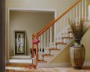
- Sheila Pree Bright (American, born 1967), Untitled 13, from the Suburbia series, 2006, dye coupler print, 49 1/2 inches, Gift of Sandra AndersonBaccus in loving memory of Lloyd Tevis Baccus, M.D., © Sheila Pree Bright, 2009.130
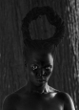

- Zanele Muholi (South African, born 1972), Zibuyile I (Syracuse), 2015, gelatin silver print, 25 5/8 x 17 inches, purchase with funds from the Donald and Marilyn Keough Family and the H. B. and Doris Massey Charitable Trust, 2017.300

