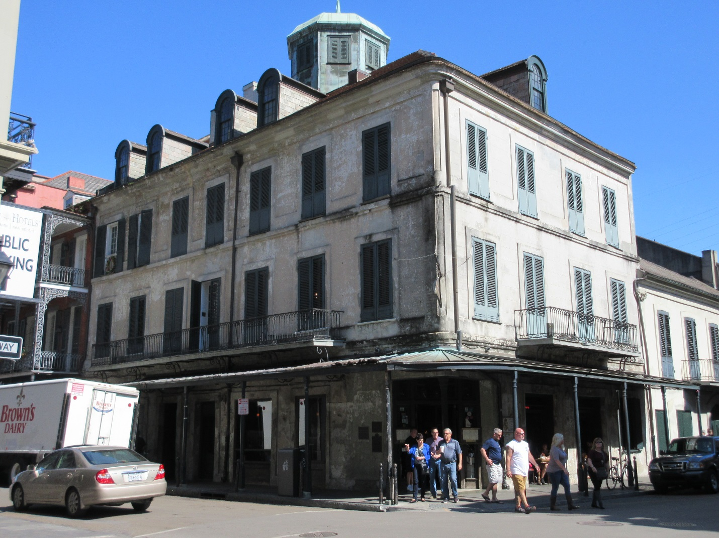1.12 Napoleon House (Girod House)
1814, attributed to Jean-Hyacinthe Laclotte. 500–506 Chartes St. (Vieux Carré)

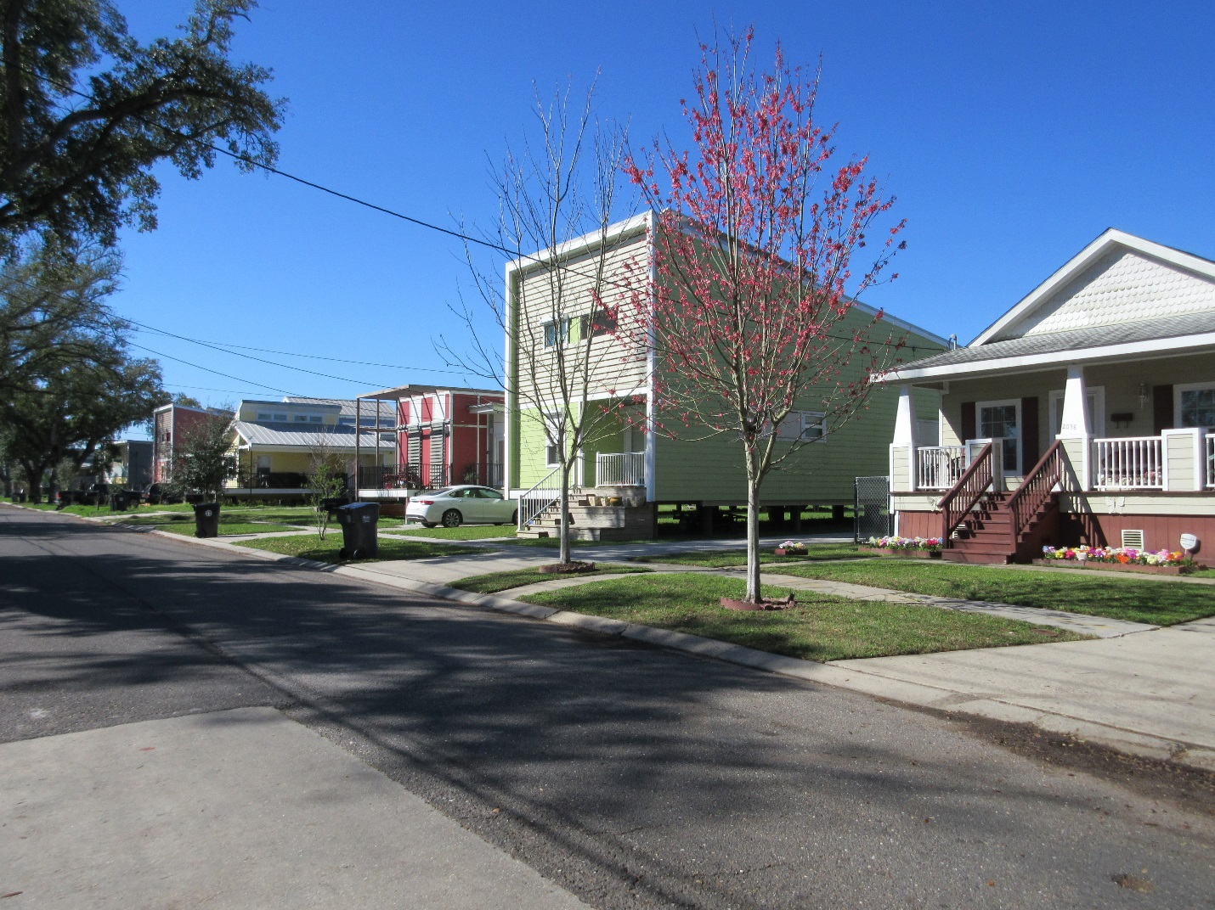3.15 Make It Right Houses
2005 and later. Roughly bounded by N. Claiborne and Jourdain aves. and Reynes and N. Galvez sts. (Lower Ninth Ward)

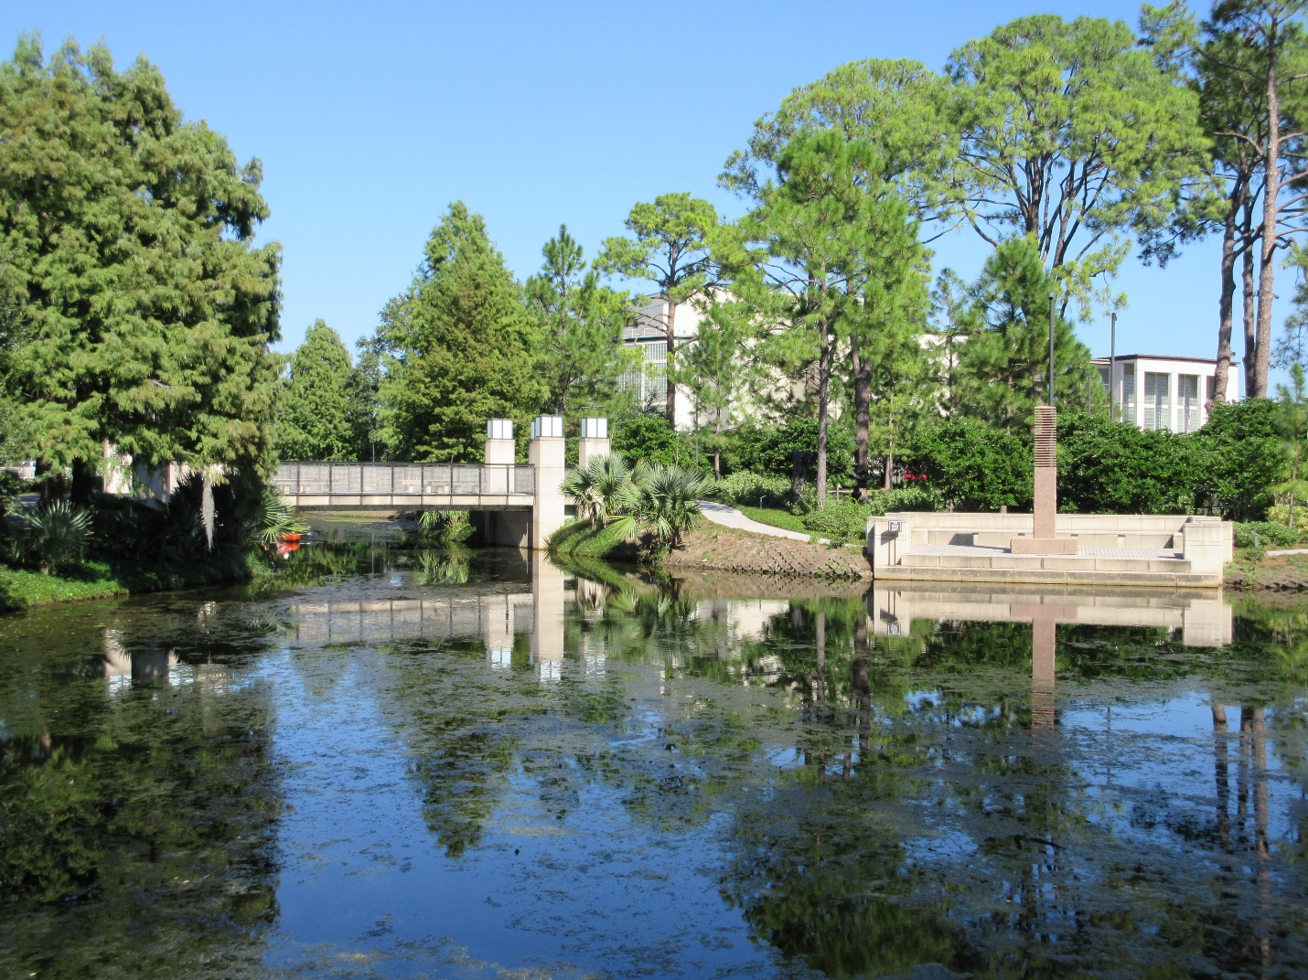4.16 Sydney and Walda Besthoff Sculpture Garden
2003, Lee Ledbetter and Associates and Sawyer/Berson. Collins Diboll Cir. (Esplanade Avenue/City Park)

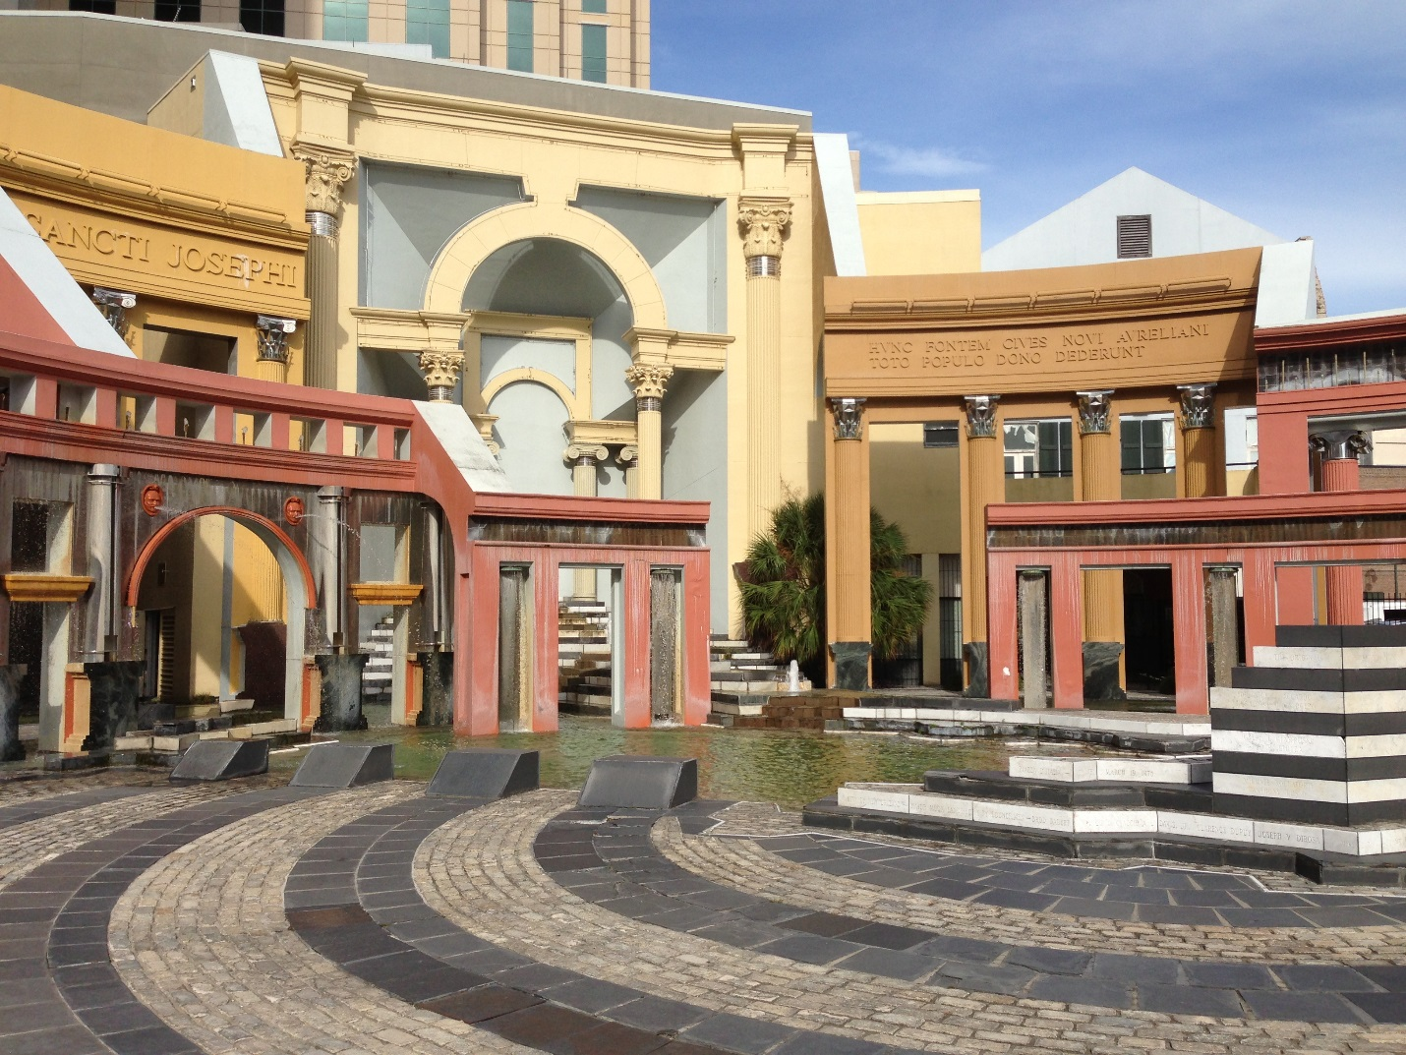6.21 Piazza d’Italia
1975–1978, August Perez and Associates, and Charles Moore for Urban Innovations Group; 2003 restored, Hewitt-Washington and Associates; 2017 renovated, Torre Design Consortium. Bounded by Poydras, Tchoupitoulas, Lafayette, and Commerce sts. (Central Business District)

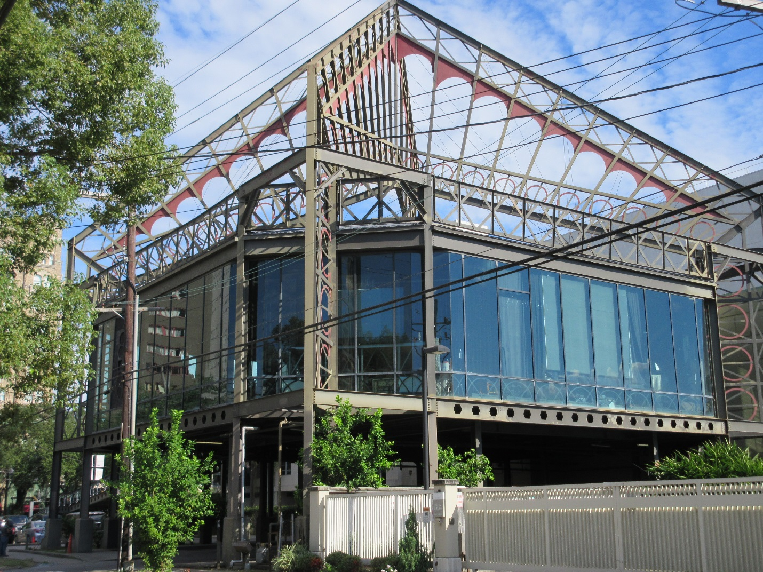7.8 The Eiffel Society (Eiffel Tower Restaurant)
1986, Concordia Architects. 2040 St. Charles Ave. (Garden District)

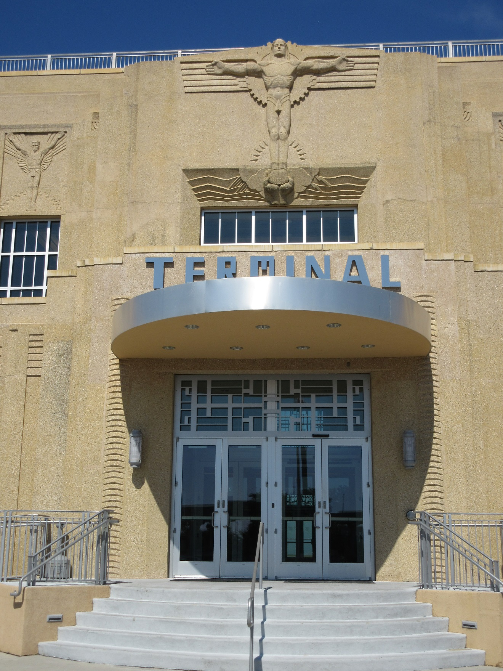11.5 Lakefront Airport (Shushan Airport)
1932–1934, Weiss, Dreyfous and Seiferth; 2013 restored, Alton Ochsner Davis. 6001 Stars and Stripes Blvd. (Lakefront)

